Inbound ISO & ISB Order Trade Engine Handling

Overview

Current processing
This is a new functionality.

New requirement
There will be two types of contingencies:
- ISO – handled as trade and cancel.
- ISO-BOOK (ISB) - handled as trade and book.

- ISO orders that cannot be handled in CBOEdirect must be CANCELLED.
- Marketable ISO orders when received by CBOEdirect must be executed immediately at CBOE’s price, regardless of whether CBOE is at the NBBO or not.
- ISO orders must not be flashed through New HAL or SAL.
- When an ISO/ISB order is executed, the trade report must be sent to OPRA, MDH and MDX/CFIX
- An ISO/ISB trade must be marked as a SWEEP trade.
  - It is to be noted that there may be XTP related work to pass along the new last sale prefix.

- If an order is marked ISO, then the order is immediately traded and any remainder is CANCELLED
- If an order is marked ISO-BOOK (ISB), then the order is immediately traded and any remainder is BOOKED, regardless of whether it Crosses or Locks an away market.

Assumption
- The IDL for Contingencies ISO and ISB will be defined.
- The New Linkage Indicator rollout flag has to be turned “ON” to start accepting these Orders.
- NBBO protection will not be provided for these types of Orders.
- These contingencies Order must not be linked away.

For detail please refer to Requirement document.

Implementation
Below are list of Classes needed they will extend BrokerLimitOrderStrategy:
- BrokerISOOrderStrategy (New)
- BrokerISBOrderStrategy (New)

Simple Order processing path for Inbound ISO and ISB:
- OrderRoutingDestinationImpl will receive the request through acceptOrder() call.
- This will invoke the isValidOrder() to valid that and in turns that will call OrderValidationOpenOutcryStrategy.validateContingency().
- By using the HandlingInstruction (passed in Order) if the Linkage rollout flag is turn “OFF” and it has received the ISO/ISB contingency then those Order will be cancelled right away.
- If the flag is turned “ON” then the Order will be processed further using BrokerServiceImpl, BrokerImpl using the Product or Class level (lock) Command Queue.
- Further AcceptOrderCommand and will use BrokerProcesserHybridImpl to processOrder().
- Actual processing of Order will be done using the appropriate strategy that can be found using BrokerStrategyFactory depending upon the type of contingency (ISO or ISB).
        - ISO Contingency: This type of contingency will use BrokerISOOrderStrategy to do the post processing using method doPostProcess() after attempting the Trade (NBBO protection will be ignored while trading) any quantity remaining will be cancelled using Order.cancel().
        - ISB Contingency: This type of contingency will use BrokerISBOrderStrategy to do the post processing using method doPostProcess() after attempting the Trade (NBBO protection will be ignored while trading) any quantity remaining will be booked using Order.handleBookProcessing().
- Trade Report generated by these contingencies will be marked as SWEEP for clearing.

Scripts
- None

Database
- Column prefix of sbt_tradereport table will marked as SWEEP.

SetContext

XML/DTD

Homes/Services
- OrderRoutingDestinationHome, OrderRoutingDestinationHomeImpl
- OrderRoutingDestination, OrderRoutingDestinationImpl

ImplPlan

Inbound ISO:
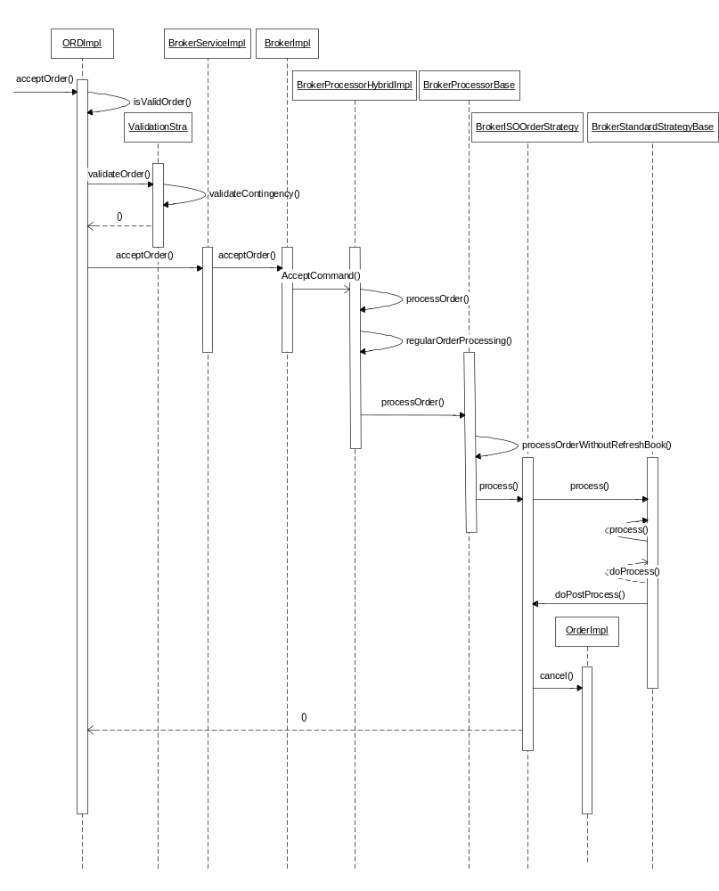

Inbound ISB:
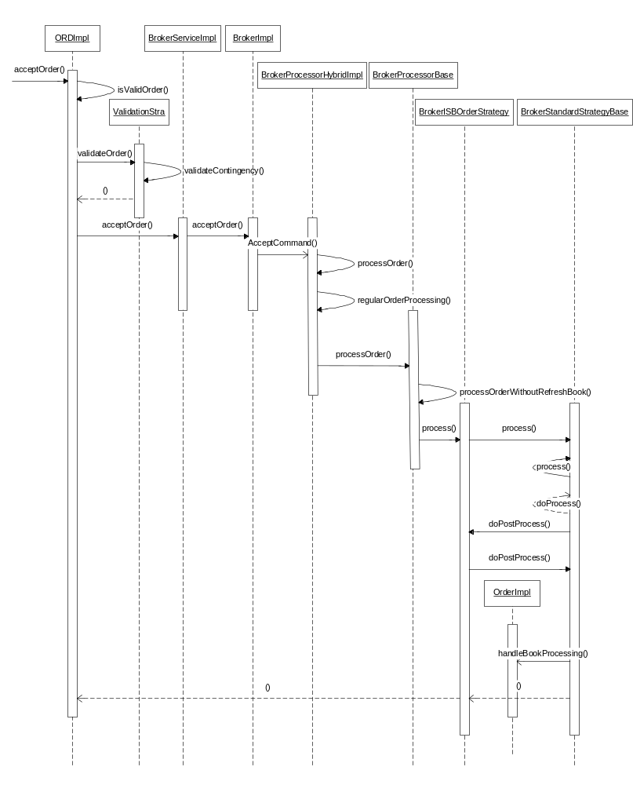

PerformanceTestingProcedure
- .

TestingProcedure

OperatorProcedure
- .

Fallback/Failover

